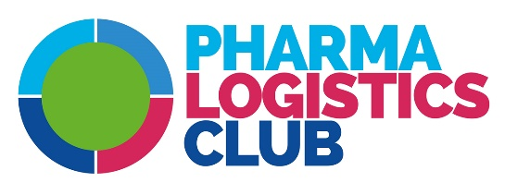
2020 MEMBERSHIP SUBSCRIPTION

I, the undersigned, Last Name: Click here to write text. First Name: Click here to write text.
From the company: Click here to write text.
Professional activity sector: Click here to write text.
Professional / Individual address: Click here to write text.
City: Click here to write text.
ZIP code: Click here to write text.
E-Mail Address: Click here to write text.
Mobile Phone: Click here to write text.
Professional Phone: Click here to write text.

Wish to become a member of the Pharma Logistics Club (please tick) for the 2019 calendar year:
As an individual member: student, looking for a job, retired | ☐ 200 € (including all taxes)
As a corporate member:
a/ Micro enterprise, SMI according to INSEE (governmental French statistic authority) criteria, Associations and Professional Federations, Administrations and local Authorities | ☐ 300 € (including all taxes)
b/ Turnover consolidated < 20 M€ | ☐ 500 € (including all taxes)
c/ Turnover consolidated ˃ 20 M€ | ☐ 750 € (including all taxes)
As a contributing member from 1000 € (including all taxes) | ☐ Amount €:

Billing (please tick)
I wish to receive the bill at the address above: ☐
I wish to receive the bill at the address below: ☐
Click here to write text.
Click here to write text.

Payment:
By IBAN transfer: FR76 1680 7004 1736 1809 0021 480 BIC: CCBPFRPPGRE
Confirmation communication to Pharma Logistics Club c/o AZ affaires, 27 rue Maurice Flandin 63003 Lyon - FRANCE
Phone +33 (0) 4 72 68 10 97 Mail: info@pharmalogistics.club

For any inquiries, don’t hesitate to contact the PLC’s treasurer Pierre Bailly: +33 (0) 6 70 82 66 29 pierre.bailly@pharmalogistics.club

☐ Personal Image Rights: I authorize the association PLC to publish my pictures on the internet site and social networks managed by the association.

CENTER OF INTEREST
☐ AIR TRANSPORT | ☐ METROLOGY / COLD CHAIN | ☐ TMS WMS SOFTWARE EDITOR
☐ DATA INTEGRITY | ☐ LEGAL / REGULATORY | ☐ SERIALIZATION
☐ SHIPPING TRANSPORT | ☐ ISOTHERMAL SYSTEMS | ☐ REFRIGERATED ROAD TRANSPORT
☐ GPD TRAINING | ☐ REGULATED TRANSPORT ADR&DGR | ☐ CUSTOMS / DRUG FALSIFICATION
☐ SECURED TRANSPORT | ☐ SOCIAL & ENVIRONMENTAL RESPONSIBILITY | ☐ OTHER

SUGGESTIONS: Click here to write text.

I declare that I read the terms of the Ethics Charter and I agree to respect it.
Place - Date: | Signature

